Hey class,

I took the Linux tutorial and I wanted to share how it went with everyone. (Caution: I am a 2308 student and have never used this before today)

Starting off, open the file that is attached. They provide this for us at the end of the lesson, but this gives a great understanding of what is happening, and many of the functions you need to know. Now for my experience.

Here are the steps we followed (For Microsoft users):

1. Download Putty - I just googled putty installer and it has the download at the top of the page.
2. Open Putty - This opens a configuration screen as shown below:

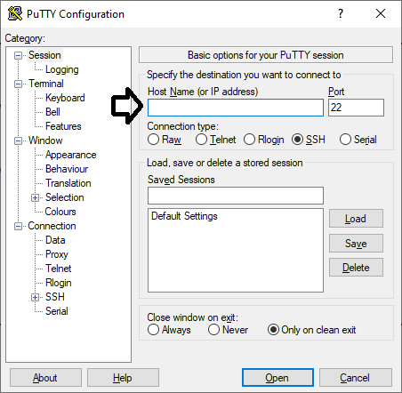

3. Under Host Name (Where the arrow is in the image) type in either eros.cs.txstate.edu or zeus.cs.txstate.edu

   - This opens Texas State's Linux Home directory that every student who takes a computer science class is enrolled into.

4. Login with your Tx State login credentials

   - It first pops up with just Login as: _____ , Type in your netID in the blank ex. jlm573

   - Next it asks for your password. It will not show anything when you start typing. So just type your password in and press enter.

5. Test different features - Now we are in the correct environment. Our instructor now showed us examples of different basic procedures.

Here is a list of features we tried out:

--------------------------------------------------------------

* Make Directory -----  "mkdir ______" ----- ex. "mkdir myDir" ----- This creates a new directory you can now work in.
* Show all files -------   "ls"                    ----- ex. "ls"                  ----- This shows all contents in the directory you are working in.
* Change directory --  "cd _____"        ----- ex. "cd myDir"       ----- This can help change between different directories.
* Open or create file - "nano _____"    ----- ex. "nano Hello.cpp" -- Here we created a blank c++ file in the console. nano will also open existing files.
* Save file -----            "ctrl x"               ----- ex. "ctrl x"                --- We wrote a simple Hello world program, to save the file, hit ctrl x, and then enter.
* Compile Program -- "g++ _____"      ----- ex. "g++ Hello.cpp" --- This will compile the program. Any errors will be shown on the screen now.
* Execute Program -- "./a.out _____"  ----- ex. "./a.out Hello.cpp" - This will execute the program and will display any output on this console.
* Remove Program -- "rm ______"     ----- ex. "rm Hello.cpp" ---    Our instructor just explained this briefly.

So this is the basics we covered. Hopefully I've covered all of this correctly, but when going through this process I just was kind of wanting a cheat sheet.

I hope this helps.

Jason McKinnerney